Behaviour of Eisenia Fetida Vermicompost on Soil-based Media Microbial Fuel Cell Performance
Aqilah Abd Halim¹, Norain Sahari^{1,*}, Zulkifli Azman³, Noor Kamalia Abd Hamed¹, Che Aqil Zulhazim Che Hassan¹, Azuwien Aida Bohari¹, Siti Maisarah Rahim², Hanafiah Kamarden⁴, and Zuraidah Ngadiron⁵
Received: May 05, 2025; Revised: August 01, 2025; Accepted: August 06, 2025
Abstract
The integration of sustainable energy generation with efficient organic waste management offers
a compelling opportunity through the application of microbial fuel cell (MFC) technologies. This study explored the enhancement of performance in soil-based MFCs through the utilisation of vermicompost sourced from Eisenia fetida, aiming to boost bioelectricity generation. Three configurations were assessed: a control (black soil), a compost-enhanced MFC (WMFC), and
a vermicompost-integrated MFC (VMFC), with regular organic waste feeding conducted over
a 50-days duration. The analysis focused on electrical outputs, soil pH dynamics, surface morphology of copper anodes, and electrochemical impedance spectroscopy (EIS). The findings indicated that VMFC demonstrated exceptional performance, reaching a peak voltage of 0.80 V, a current density of 10.764 mA/m² and a power density of 5.056 mW/$m^{2}$. This success can be linked to increased microbial activity and effective electron transfer, which were supported by the decomposition of substrates mediated by earthworms. Scanning electron microscopy (SEM) imaging revealed significant biofilm formation on VMFC anodes, whereas EIS demonstrated minimal charge transfer resistance. The results highlighted the combined impact of vermiculture and microbial groups in enhancing MFC efficiency, presenting a scalable approach for bioenergy production and the value addition of organic waste in sustainable environmental systems.
Keywords: Bioelectricity generation; Eisenia fetida; Electrochemical performance; Microbial fuel cells; Sustainable waste management; Vermicompost
¹ Department of Electrical Engineering Technology, Faculty of Engineering Technology, Universiti Tun Hussein Onn Malaysia, 84600 Muar, Johor, Malaysia. E-mail : aqilahabdhalim98@gmail.com; norains@uthm.edu.my ; kamalia@uthm.edu.my; cheaqilzulhazim@gmail.com; azuwien@uthm.edu.my
² Department of Electronic Engineering, Faculty of Electrical and Electronic Engineering, Universiti Tun Hussein Onn Malaysia, Parit Raja 86400 Malaysia. E-mail : zulkifli.bin.azman@gmail.com.
³ Department of Laboratories Management, Faculty of Applied Science and technology, Universiti Tun Hussein Onn Malaysia, 84600 Muar, Johor, Malaysia. E-mail: maisarah@uthm.edu.my.
⁴ AAF Bioscience PLT, Johor Bahru, 80250, Malaysia. E-mail : aafbioscience@gmail.com.
⁵ Power Integration System (PI Sys), Faculty of Electrical and Electronic Engineering, Universiti Tun Hussein Onn Malaysia, Parit Raja 86400 Malaysia. E-mail : zuraidahn@uthm.edu.my.
* Corresponding author
DOI: https://doi.org/10.55766/sujst9738
Suranaree J. Sci. Technol. 33(1):030369(1-12)

Introduction
The increasing worldwide demand for sustainable energy solutions and effective waste management has prompted academics to investigate novel bio-electrochemical technologies. Given the escalating environmental issues, including greenhouse gas emissions, soil degradation, and the overaccumulation of organic waste, there is an imperative for integrated strategies that concurrently tackle waste management and renewable energy production (Enebe, 2023), (Ramanaiah et al., 2023). Conventional waste management techniques, such as landfilling and incineration, exacerbate pollution and deplete resources, while traditional energy sources persist in undermining environmental sustainability. MFCs have emerged as a viable technique to turn organic waste into electricity while facilitating bioremediation.
MFCs are bio-electrochemical systems that employ electroactive bacteria to decompose organic materials and produce energy. These systems function by enabling electron transfer from microbial metabolism at the anode to an electron acceptor at the cathode, thereby generating bioelectricity (Pandya et al., 2024). The configuration of MFCs plays a crucial role in determining their performance. Dual-chamber MFCs, typically used for wastewater treatment, separate the anode and cathode into two compartments divided by a proton exchange membrane, allowing for controlled redox reactions. In contrast, single-chamber MFCs place both electrodes in one compartment and are more cost-effective and suitable for soil-based or vermicompost applications due to their structural simplicity and compatibility with solid substrates (Bazina et al., 2023).
This technology has been extensively studied for its prospective use in wastewater treatment, soil remediation, and bioelectricity generation. Nonetheless, despite its significant promise, limited power output and variable microbial activity continue to pose substantial obstacles to the widespread adoption of MFCs (Jalili et al., 2024). Recent research has investigated the utilisation of vermicompost as an electrolyte to improve MFC performance, owing to its significant microbial variety and enzymatic activity (Ratnasari et al. 2023). Vermicomposting is a biological process utilising earthworms, such as Eisenia fetida, to degrade organic waste into nutrient-dense compost. This technique promotes soil fertility and sustains microbial populations, rendering it an optimal substrate for MFCs (Singh et al. 2011). Research
has shown that vermicompost enhances the availability of organic matter, consequently enhancing microbial metabolism and electron transfer efficiency in microbial fuel cells (Moqsud et al., 2015).
In addition, the choice of earthworm species plays a vital role in determining the efficiency of vermicompost-based MFCs. Among various species studied, Eisenia fetida stands out due to its high adaptability, reproduction rate, and enzymatic synergy with microbial communities. A study by Florentios Economou (2024) found that MFCs using vermicompost processed by Eisenia fetida achieved a peak power density of 192 mW/m², outperforming MFCs using Eudrilus eugeniae or native species, which yielded less than 140 mW/m² under similar conditions. The superior bio-electrochemical performance is attributed to enhanced microbial diversity, better substrate decomposition, and improved pH buffering within the vermicompost layer (Economou et al., 2024). Despite the exploration of different configurations, such as dual-chamber and soil-based single-chamber MFCs, their practical implementation is constrained by issues including low power output, internal resistance, and microbial instability.
Recent studies have investigated the application of compost-based substrates, such as vermicompost, to enhance MFC performance through the improvement of microbial diversity and nutrient availability (Castellini et al., 2024). Nonetheless, the comprehension of how environmental factors like pH variation, feeding frequency, and vermiculture activity affect the electrogenic performance of MFCs, especially in solid-state, soil-based systems, remains limited.
In this study, the bioelectric performance of three MFC configuration systems, namely Control (black soil only), compost-based (WMFC), and vermicompost-enhanced (VMFC), was examined under different organic waste feeding regimes. Feeding referred to the periodic top-up of natural waste (40g) every 10 days to sustain in-situ composting within the MFC chambers. Experiments were conducted to evaluate the effects of continuous and interrupted feeding cycles on compost activity, pH stabilization, and power generation over time of the three electrolyte systems. Throughout the experiments, critical performance metrics were assessed in terms of voltage and current output, and pH variations. Scanning electron microscopy (SEM) was employed to analyse the anode surface morphology. In addition, electrochemical impedance spectroscopy (EIS) was used to determine the internal resistance and conditions that optimally augmented power generation and microbial activity in soil-based MFC systems. Unlike previous studies that primarily assessed static compost conditions, this study uniquely investigated the impacts of dynamic feeding regimes, specifically, the periodic addition of 40g of natural waste every 10 days, on in-situ composting activity, pH stability, and long-term power generation.
Materials and Methods
MFC Circuit and Energy Conversion
A basic MFC circuit employs a bio-electrochemical mechanism to convert the metabolic energy of organic materials into electrical energy. The system comprises a 470Ω resistor functioning as the external load, along with
a cathode (negative terminal) and an anode
(positive terminal) (Imologie, 2016), as illustrated in Figure 1.

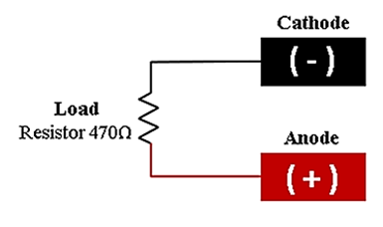

Figure 1. Schematic of the MFC stack
Microorganisms decompose organic materials at the anode, releasing protons and electrons simultaneously. To complete the reaction and generate water, electrons traverse the external circuit to the cathode, where they combine with protons and oxygen. The resistor facilitates the measurement of electrical output, particularly voltage and current, while emulating an energy-demanding apparatus. This arrangement establishes a basis for energy generation efficiency optimization, while elucidating the fundamental operation of the MFC.

Vermicompost Preparation and MFC Setup
The preparation of vermicompost soil began with the collection of organic waste materials, including food remnants and plant debris. These materials were placed into a specific composting bin containing appropriate substrate to establish the vermicomposting system. Black soil used as the base electrolyte in all MFC chambers was purchased from Ban Guan Nursery (Johor, Malaysia). The soil was sieved to remove rocks and large organic matter, and used without sterilization to preserve native microbial populations. No additional fertilizer or chemical amendments were added. To enhance the decomposition process,
15 mature Eisenia Fetida earthworms were introduced into the system, ensuring optimal microbial activity and organic matter breakdown for effective vermicompost formation.
Optimal conditions for effective vermicomposting were achieved by methodically maintaining key elements such as soil moisture, temperature, and aeration during the composting phase. Soil moisture was maintained within an estimated range of 80%-90% and adjusted every three days using distilled water based on readings from the soil moisture meter. The ambient laboratory temperature ranged from 26°C to 31°C . All MFCs were maintained under natural airflow settings, with chambers loosely covered to ensure aerobic conditions and prevent contamination. No active aeration was utilised, as microbial respiration was facilitated by passive air-soil contact. Consistent monitoring and modifications were conducted to support efficient organic material decomposition. The composting process persisted until the material evolved into mature vermicompost, distinguished by its black, granular texture and abundant nutrient composition. The electrolyte pH in each chamber was measured daily using 4-in-1 soil survey instrument (Model: KC-300B). The probe was carefully inserted into the dirt at the center of each chamber, avoiding contact with electrodes. Measurements were recorded once the reading stabilized. This in-situ, non-destructive technique enabled continuous monitoring of pH fluctuations throughout the experiment, facilitating observation of composting dynamics and their impact on MFC performance. The materials and apparatus employed in this work, as depicted in Figure 2, were meticulously chosen to guarantee experimental accuracy and reliability. Enameled copper rods, purchased from VTECHN (Kelantan, Malaysia), served as anodes owing to their superior conductivity and stability. Aluminum mesh, purchased from Stage 2 Hardware (Penang, Malaysia), was selected as cathodes for its lightweight nature and cost-effectiveness. The outer layer of the copper rod, measuring 155cm, was scraped and shaped into 12cm × 12cm square spiral, while the aluminum mesh was cut into 12cm × 12cm square (Lo, 2023).
The electrolytes were utilised in the MFCs. Single-chamber MFCs were selected for their simplicity and efficacy in examining bio-electrochemical processes. Voltage and current outputs were measured using digital multimeter to ensure accurate and consistent data collection.
Experimental Design

Table 1. Parameters for all MFC chambers

MFC | Organic waste (g) | Number of Earthworms
Control | - | -
WMFC | 40 | -
VMFC | 40 | 15

The experimental setup consisted of three distinct MFC configurations. Each MFC chamber contained 1520g of black soil as the principal medium. The Control setup contained only black soil, serving as the baseline condition without any organic waste. The WMFC setup integrated black soil with organic waste to evaluate the effect of organic material on electrical output. The VMFC contained black soil, the same organic waste as WMFC, and earthworms, representing a solid vermicompost system. To monitor the effect of continuous substrate availability on microbial activity and MFC performance, 40g of organic waste was added to both WMFC and VMFC at 10-day intervals throughout the experimental period. This regular feeding regime enabled the observation of changes in voltage and current output in response to fresh nutrient input.
The organic waste utilised in both WMFC and VMFC consisted of banana peel (10g), mango peel (10g), potato peel (10g), and dried leaves (10g). All MFC chambers were equipped with identical electrodes, with copper spiral serving as the anode, and aluminum mesh as the cathode. This standardization guaranteed that variances in electrical output were predominantly attributable to disparities in microbial activity and electrolyte composition, rather than discrepancies in electrode materials. The experimental design facilitated
a comparative analysis to identify the most efficient medium for power generation. The specifications of each chamber are presented in Table 1.

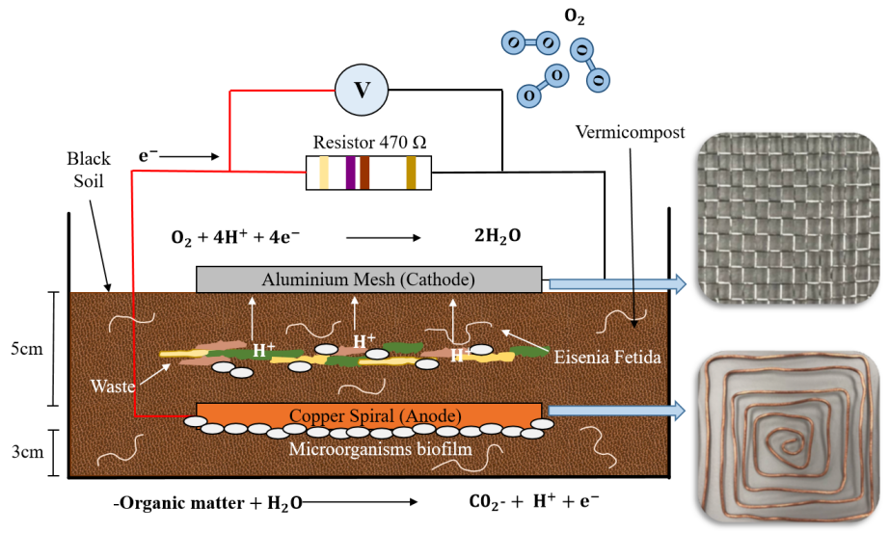

Figure 3. MFC schematic diagram
Figure 3 depicts the schematic diagram and cross-sectional view of the VMFC, illustrating the configurations of the anode and cathode, as well as the associated chemical reactions. The electrode arrangement was identical across all MFC chambers

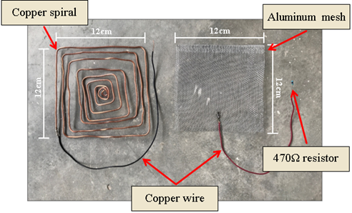

Figure 2. Electrodes for anode and cathode
The respective electrolytes were added to each chamber, with identical volumes maintained to ensure a fair and consistent comparative analysis. Each MFC was linked to a data acquisition system that incessantly monitored and recorded voltage and current outputs at predetermined time intervals. The collected data were analysed to assess and compare the electrical production efficacy of each MFC configuration according to its distinct electrolyte composition. Energy generation in MFC is fundamentally driven by the metabolic functions of electroactive bacteria, which oxidize organic substrates at the anode. This bio-electrochemical reaction liberates electrons and protons, establishing the basis for current generation. The universal anode reaction occurring in all MFC chambers, irrespective of the individual substrate, is as follows: Organic matter + H₂O → CO₂ + H⁺ + e⁻
In this reaction, microorganisms break down complex organic chemicals found in soil or organic waste into simpler molecules (Zhou et al., 2012). Water molecules facilitate the hydrolysis of these chemicals, resulting in the liberation of carbon dioxide (CO₂), protons (H⁺), and electrons (e⁻). The electrons traverse externally over a conductive circuit toward the cathode, producing electricity, while the protons migrate internally through the electrolyte toward the cathode to complete the redox reaction. In environments rich in organic inputs, such as food waste, more specialized substrates like glucose (C₆H₁₂O₆) may appear as intermediates of decomposition. Under such conditions, the anode reaction can be represented as: C₆H₁₂O₆ + 6H₂O → 6CO₂ + 24H⁺ + 24e⁻. In this process, each glucose molecule is fully oxidized into six carbon dioxide molecules, concurrently releasing 24 protons and 24 electrons. The elevated electron yield results in enhanced electrical production, which is commonly seen in MFCs enriched with nutrient-dense organic waste.
Molecular oxygen from the environment serves as the ultimate electron acceptor at the cathode. The electrons from the external circuit and the protons from the anode react with oxygen in the subsequent reduction reaction: O₂ + 4H⁺ + 4e⁻ → 2H₂O. To enhance clarity and comprehension of the bio-electrochemical pathways involved in this study, Table 2 summarizes the typical chemical species, their molecular structures, and their relative roles in the MFC operation.

Table 2. Key chemical molecules and reactions in soil-based MFC

Molecule | Chemical reaction | Structure | Role in MFC
Glucose | C₆H₁₂O₆ | 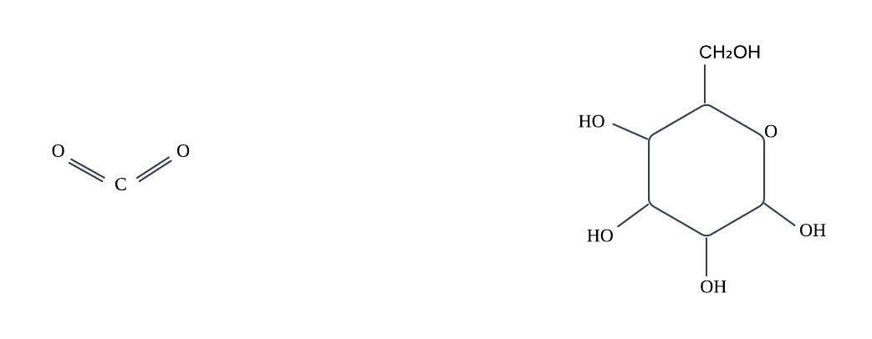 | Fuel at anode
Water | H₂O | 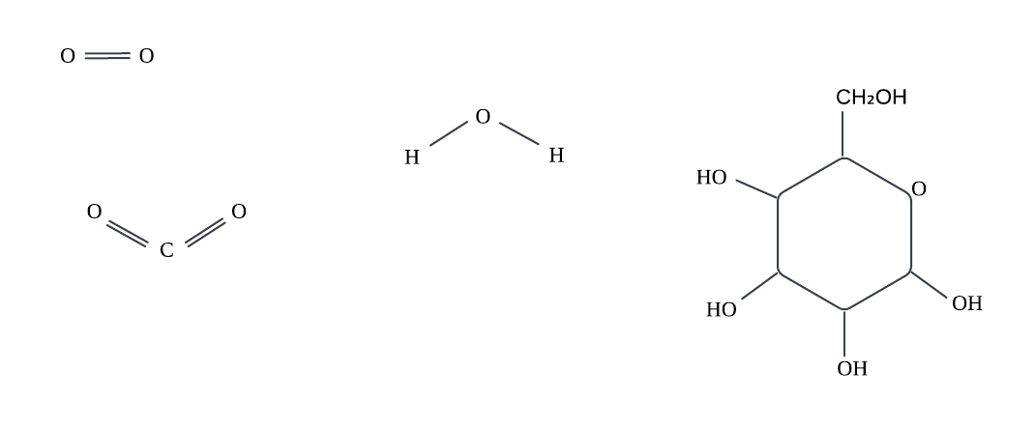 | Supports proton flow
Carbon dioxide | CO₂ |  | Waste from oxidation
Protons | H⁺ | - | Proton carrier
Electrons | e⁻ | - | Generates electricity
Oxygen | O₂ |  | Accepts electrons

This process finalizes the electrical circuit and restores water, maintaining charge neutrality within the cell. The comparative investigation of various chambers, including Control, WMFC, and VMFC, demonstrated that fluctuations in organic matter supply directly affected the intensity and sustainability of redox reactions. These observations highlight the importance of substrate composition and microbial dynamics in maximizing MFC energy production (Yang and Yang, 2020).

Data Collection and Analysis
A thorough data collection was performed to observe the dynamic behaviour of MFC devices. Key parameters measured included soil moisture, ambient and soil temperature, markers of microbial activity, and electrical outputs. These variables were logged either continuously or periodically to record system reactions under varying organic waste input conditions. A rigorous analytical approach was utilised to assess the performance and energy generation capacity of each chamber. Correlation analyses between environmental factors and bio-electrochemical outputs were performed to elucidate the interdependence between microbial metabolism and electrochemical efficiency.
Statistical analysis, encompassing correlation matrices, trend analysis, and fundamental inferential statistics, was conducted utilising OriginPro software. This analysis revealed how particular situations, such as the inclusion of food waste, influenced voltage fluctuations, current peaks, and pH stability. These assessments aimed to quantify system performance and identify key operational conditions necessary for stable energy output. The comparative analysis of MFCs provided significant insights into microbial adaptation and electrogenic performance under various substrate conditions.
Results and Discussion
Effect of organic waste and vermiculture on MFC electrical characteristics
The electrical performance of the three MFC configurations (Control, WMFC, and VMFC), measured in terms of voltage, current, and power over time, was evaluated over 50 days. This timeframe encompassed dynamic feeding phases: continuous substrate addition from Day 1-20,
a starvation phase from Day 20-30, and refeeding cycles from Day 30-50. As depicted in Figure 4, all systems exhibited an initial increase in voltage output during the startup phase (Day 1-10), with the VMFC configuration achieving the highest peak voltage (~0.75 V), followed by WMFC (~0.67 V) and Control (~0.6 V). This was likely due to the presence of earthworms, which accelerated organic matter breakdown and enhanced microbial activity through their secretions, such as mucus, urine, and feces, thereby stimulating the proliferation of electroactive bacteria.
Organic waste was replenished on Day 11. The voltage stabilization observed from Days 10-
20 reflected effective substrate utilisation and microbial acclimatization. As shown in Figure 4,
a noticeable decline in output voltage was observed in both compost and vermicompost MFCs starting from Day 18 onwards. This suggests that, without consistent waste replenishment, the microbial community rapidly transitions into a nutrient-depleted phase. The effect is especially prominent in the VMFC, which relies heavily on the synergistic relationship between earthworms and microbial populations. Once the substrate is exhausted, earthworm activity diminishes, leading to reduced microbial stimulation and, potentially, the release of inhibitory compounds due to stress or starvation.
No additional waste was introduced between Day 20 and Day 30, resulting in 10-day starvation period. During this phase, a significant and sharp decline in electrical output was observed in all systems, particularly in the VMFC. This decline was likely due to the continued metabolic activity of earthworms in the absence of food sources. Under starvation conditions, earthworms may consume beneficial microbial biomass or release metabolic byproducts that are detrimental to the electroactive microbial community (Nandy et al., 2015). Organic waste was reintroduced on Day 30, replicating the initial experimental setup. As observed previously, the output voltage gradually increased in all MFC configurations, with the VMFC again demonstrating the highest performance. This reinforces the critical role of waste replenishment in sustaining electrochemical activity. The similarity in output trends confirms the repeatability of the system’s behaviour and the validity of the observed performance patterns.
To investigate the optimal replenishment frequency, organic waste was added more frequently on Day 40 and Day 45. The results demonstrated that a 5-day waste top-up cycle significantly improved output stability and voltage magnitude, particularly in the VMFC. This suggests that a continuous supply of biodegradable substrate not only supports a stable microbial community but also ensures active participation of earthworms in organic matter degradation and microbial stimulation. Under this feeding regime, the VMFC consistently outperformed both the WMFC and Control, highlighting its superior electrogenic potential when properly maintained.
Starvation led to a marked increase in current density output for both the VMFC and WMFC, as shown in Figure 5, whereas the Control maintained a relatively stable but lower current density, reflecting its limited metabolic activity. Upon substrate replenishment, the current output rebounded sharply in the VMFC, reaffirming its superior electron transfer capability (Simeon et al., 2022).
The current density versus time profile normalized these outputs, with the VMFC achieving a maximum current density of 10.764 mA/m². The steep decline observed after the starvation phase, to 2.778 mA/m², followed by subsequent recovery, underscores the sensitivity and adaptability of the vermicompost-enhanced microbial community.
Among the three configurations, the VMFC chamber exhibited the highest power output, reaching a peak power density of 5.056 mW/m². This result implied improved electrogenic activity following waste refeeding, which contributed to pH stabilization and enhanced microbial metabolism throughout the composting cycle.

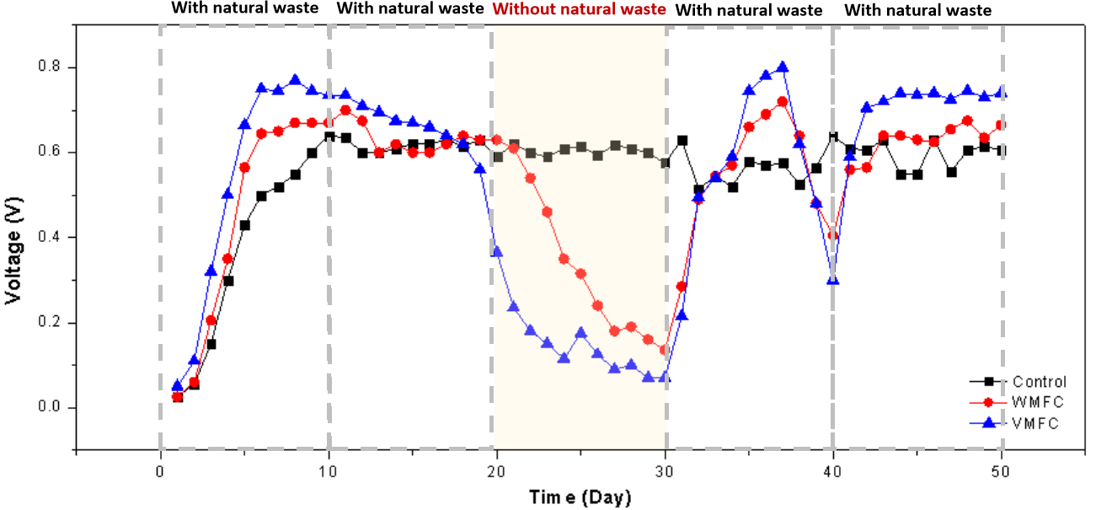

Figure 4. Voltage versus time output of Control, WMFC, and VMFC over 50 days under feeding, starvation, and refeeding phases

Compared to previous studies utilising vermicompost as a bio-electroactive substrate in MFCs with various anode materials, Ratnasari et al. (2023) achieved voltage of 0.57 V and power density of 3.6 mW/m² using carbon cloth and cattle manure-derived vermicompost. Similarly, Singh
et al. (2011) reported 0.51 V and 2.8 mW/m² with carbon felt, vermicompost, and municipal waste. In contrast, the VMFC chamber in this study achieved peak voltage of 0.80 V and power density of
5.056 mW/m². These improvements highlight the role of both the vermicompost’s active microbial community and the copper anode’s superior electron transfer capability, reinforcing the importance of electrode selection in optimizing MFC output.

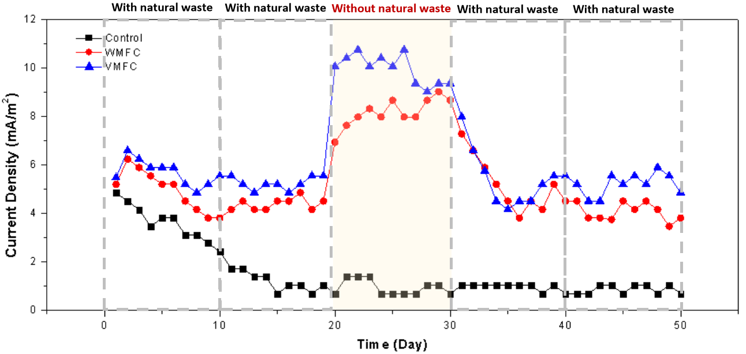

Figure 5. Current density versus time output of all MFC configurations during 50 days of operation

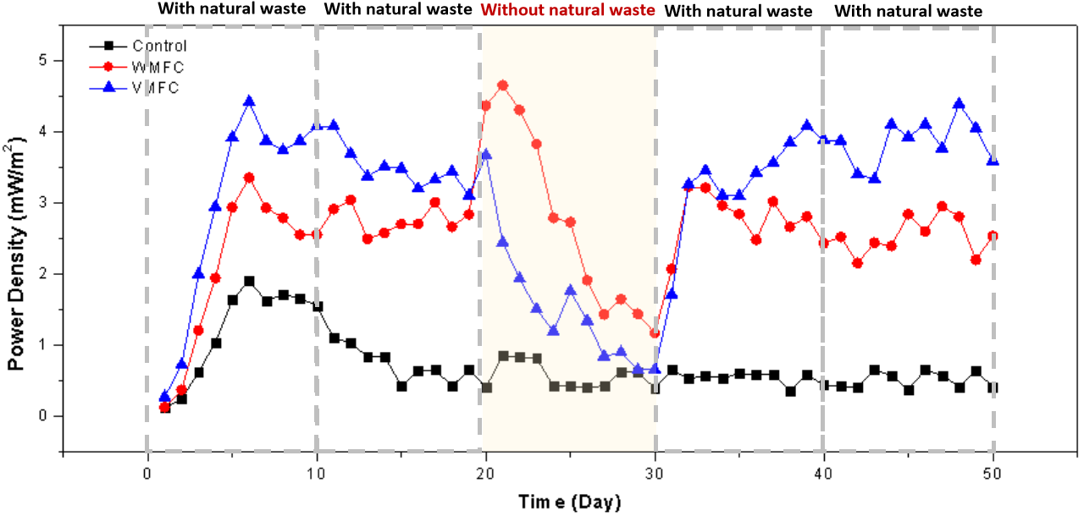

Figure 6. Power density versus time trends for Control, WMFC, and VMFC

The VMFC configuration consistently outperformed both the WMFC and Control across all electrochemical parameters during feeding periods, affirming that the synergistic interaction between natural waste and earthworms substantially enhanced MFC efficiency. The dynamic reaction observed during starvation and refeeding phases, as illustrated in Figure 6, underscores the system’s resilience and its potential for scalable, sustainable bioelectricity generation and organic waste treatment (Cui et al., 2024).
The comparative analysis of the Control, WMFC, and VMFC systems over 50-day period indicated that the incorporation of organic waste markedly improved MFC performance, especially when integrated with vermiculture. The noted decrease in performance during the starvation phase, followed by a swift rebound post-refeeding, highlights the significance of stable substrate supply and the resilience of microbial communities fueled by vermicompost. These findings corroborate prior studies demonstrating that vermiculture, particularly using Eisenia fetida, accelerates organic matter decomposition and promotes diverse microbial communities that enhance electron transfer rates (Khare et al., 2013). Moreover, the improved performance of the VMFC corroborates increasing evidence that organic substrates not only drive microbial respiration but also maintain long-term electrochemical stability (Ratnasari et al., 2023). Consequently, VMFC offers a viable method for scalable, sustainable energy production and organic waste treatment in soil-based MFCs (Toczyłowska-Mamińska, et al., 2025).

Effect of soil pH level on MFC voltage output
The relationship between voltage and pH levels in the Control, WMFC, and VMFC systems during the 20-day refeeding phase, as shown in Table 3, offers significant insights into the impact of microbial activity and waste composition on electrochemical performance. Initially, the Control system exhibited a reasonably constant voltage output and minimal pH fluctuation, signifying restricted microbial metabolism in the absence of supplemental organic matter. In contrast, both the WMFC and VMFC exhibited a distinct rising trend in voltage output as pH progressively increased from Day 30 to Day 36. This tendency infers that organic waste and vermicomposting provide biodegradable substrates that enhance microbial respiration, thus facilitating increased electron synthesis (Chae et al., 2009).

Table 3. Voltage-pH relationship in MFCs

Day | Voltage (V) |  |  | pH
Day | Control | WM  FC | VM  FC | Control | WM  FC | VM  FC
30 | 0.58 | 0.14 | 0.07 | 7.8 | 5.4 | 4.1
31 | 0.63 | 0.29 | 0.22 | 7.7 | 5.9 | 5.2
32 | 0.51 | 0.49 | 0.50 | 7.7 | 6.5 | 6.7
33 | 0.55 | 0.55 | 0.54 | 7.5 | 7.4 | 7.1
34 | 0.52 | 0.57 | 0.59 | 7.6 | 7.7 | 7.2
35 | 0.58 | 0.66 | 0.75 | 6.8 | 7.8 | 7.5
36 | 0.57 | 0.69 | 0.78 | 7.1 | 7.8 | 7.8
37 | 0.58 | 0.72 | 0.80 | 7.1 | 7.8 | 7.8
38 | 0.53 | 0.64 | 0.62 | 6.8 | 7.5 | 6.9
39 | 0.57 | 0.48 | 0.48 | 6.5 | 6.8 | 6.7
40 | 0.64 | 0.41 | 0.30 | 7.5 | 5.4 | 5.4
41 | 0.61 | 0.56 | 0.59 | 7.3 | 6.5 | 6.7
42 | 0.61 | 0.57 | 0.71 | 7.3 | 6.8 | 7.5
43 | 0.63 | 0.64 | 0.72 | 6.5 | 7.3 | 6.9
44 | 0.55 | 0.64 | 0.74 | 7.2 | 7.5 | 7.5
45 | 0.55 | 0.63 | 0.74 | 6.5 | 7.5 | 7.3
46 | 0.63 | 0.63 | 0.74 | 6.9 | 7.5 | 7.0
47 | 0.56 | 0.66 | 0.73 | 6.9 | 7.3 | 6.7
48 | 0.61 | 0.68 | 0.75 | 7.3 | 7.1 | 6.7
49 | 0.62 | 0.64 | 0.73 | 6.9 | 7.3 | 6.8
50 | 0.61 | 0.67 | 0.74 | 6.9 | 7.3 | 6.7

The VMFC system, using earthworms, attained the maximum voltage output and optimal pH stability at 7.5 during peak performance days (Days 35-37). This indicated an improved buffering capacity and heightened redox activity, likely enabled by the vermicomposting process. As noted by Barua and Deka (2010), earthworms facilitate aeration, enhance microbial variety, and promote rapid degradation, and vermicompost-augmented MFCs yield increased voltage due to synergistic microbial consortia. However, following Day 38, both the WMFC and VMFC experienced a decline in pH, which corresponded with a reduction in voltage.
pH is a crucial determinant that directly affects microbial metabolic activity in MFC systems. The majority of electrogenic bacteria exhibit optimal performance under neutral conditions, specifically within the pH range of 6.5 to 7.5. When pH levels are excessively acidic, microbial respiration is inhibited, leading to decreased electron production for energy generation. The findings of this study demonstrated voltage recovery to nearly neutral pH levels, highlighting the imperative of balanced pH in enhancing microbial activity and MFC performance. This corresponds with the findings of Abourached et al. (2014), who emphasized that pH levels below neutral impede microbial metabolic activity, hinder proton transfer, and elevate internal resistance, ultimately reducing voltage generation (Yang et al., 2016). A favourable correlation existed between neutral pH conditions and enhanced power output in microbial electrochemical systems. Malaeb et al. (2013) confirmed that a pH range of 6.5 to 7.5 provides excellent conditions for the proliferation of Ex-electrogenic bacteria and the successful progression of electrochemical processes at the anode (Amendola and Amit, 2022).
Ambient temperature and soil moisture were monitored daily throughout the experiment. Recorded ambient temperature ranged from 26°C to 31°C, and soil moisture levels remained within 80% - 90%. Nonetheless, no substantial relationship was detected between these parameters and voltage output across all MFC chambers. Conversely, changes in pH exhibited a more pronounced and direct effect on microbial metabolic activity and power generation. Therefore, this study primarily focused on pH and organic waste refeeding as the predominant contributing elements in enhancing MFC performance.

Surface Morphology of Copper Anode
The surface morphology of copper anodes from the three MFC configurations, as shown in Figure 7, was analysed using scanning electron microscopy (SEM) and demonstrated significant disparities. These morphological variations reflected differing levels of microbial colonization and electrochemical interaction. The observed disparities can be ascribed to the distinct environmental and biological components inherent to each MFC configuration (Amendola and Amit, 2022).
In the Control chamber, SEM imaging revealed a comparatively smooth anode surface with few abnormalities or stratifications. The anode exhibited few textural alterations and minimal particle buildup, indicating restricted microbial
engagement. This discovery corresponds with the diminished and consistent current and voltage output recorded during electrochemical testing, suggesting a less active electrogenic microbial community, which is attributed to nutritional deficiency stemming from the absence of supplemental substrates.

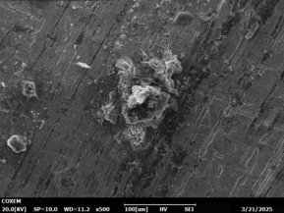

(a)

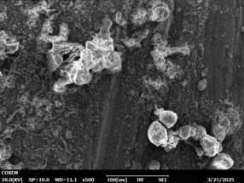

(b)

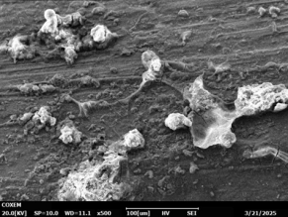

(c)

Figure 7. SEM images of anode surfaces from each MFC configuration: (a) Control, (b) WMFC, and (c) VMFC
Similar findings were reported by Daud et al. (2021), who noted that limited biofilm growth occurred on electrodes in nutrient-deficient settings, resulting in diminished MFC performance (He
et al., 2011).
In contrast, the anode from the WMFC chamber exhibited a more uneven and stratified surface under SEM analysis. The micrograph displayed irregular textures along with potential signs of extracellular polymeric substances (EPS) and deposits, indicative of nascent biofilm formation. These characteristics were probably due to heightened microbial activity induced by the presence of organic substrates, amplifying electrogenic processes at the anode. This interpretation is further supported by the elevated and varied voltage and current outputs. Nawaz et al. (2024) highlighted that the availability of biodegradable substrates enhances EPS generation and biofilm formation, both of which are essential for effective electron transfer in MFCs (Logan
et al., 2006).
The most significant structural alterations were noted on the anode from the VMFC chamber, comprising black dirt, organic waste, and vermiculture (Eisenia fetida). The SEM images displayed a clear layered biofilm-like structure characterized by significant surface roughness and mineral accumulation (Sharafat et al., 2022). Although individual microbial cell morphologies were not discernible, possibly due to the prevalence of EPS or soil mineral coatings, the significant alterations aligned with advanced biofilm maturation. The presence of earthworms improved substrate breakdown and oxygenation, fostering
a rich and dynamic microbial community that enabled increased electron transfer. This was evident in the enhanced electrochemical performance of the VMFC chamber. Research conducted by Khater et al. (2023) revealed that vermicomposting markedly enhances microbial variety and activity, resulting in improved biofilm formation and MFC efficiency (Khater et al. 2023). While individual microbial cells were not discernible in the SEM images, presumably due to the intricacy of the soil matrix and the presence of EPS, the layered textures and surface roughness observed in both WMFC and VMFC chambers strongly indicated microbial colonization. These findings are consistent with prior research, which documented analogous morphologies as indicative of biofilm activity in MFC environments (Hidalgo et al. 2016).
This SEM analysis underscores the influence of substrate composition and vermicompost treatment on microbial activity and anode surface alteration. The results indicated that, although biofilm formation may not consistently manifest in traditional microbial morphologies, SEM imaging is an essential technique for assessing the presence of electrogenic microbes in intricate, soil-based MFC systems.
Electrochemical Impedance Spectroscopy
The Nyquist plots in Figure 8, derived from electrochemical impedance spectroscopy (EIS), did not exhibit a clearly defined semicircular arc, which is typically representative of charge transfer resistance ($R_{ct}$) and diffusion-related impedance, respectively. This divergence from optimal performance is anticipated in soil-state, soil-based MFCs due to the heterogeneous composition of the matrix, fluctuating ion mobility, and intricate microbial colonization patterns. Although there was no pronounced arc, the general impedance trend revealed that the VMFC system exhibited the lowest internal resistance, aligning with its enhanced electrical performance. This indicated improved electron transport and microbial activity, even in the suboptimal electrochemical circumstances typical of soil-based MFC systems.

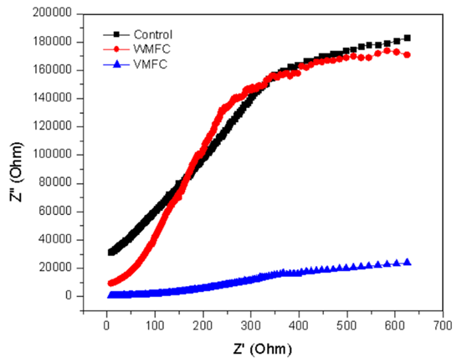

Figure 8. Nyquist plot analysis for Control, WMFC, and VMFC
The Control displayed the greatest arc diameter and highest imaginary component, signifying considerable internal resistance and inadequate charge transfer efficiency. This finding aligns with the literature that a deficiency of organic substrates in MFCs can significantly impede microbial metabolic activity and, consequently, electron transfer efficiency (Logan et al., 2006). Conversely, the WMFC exhibited a decrease in both real and imaginary impedance components, indicating enhanced electrochemical performance. This improvement was due to the increased availability of biodegradable organic debris, which acted as a carbon source for electrogenic bacteria. Li et al. (2016) similarly showed that food waste markedly increases microbial activity and bioelectricity production owing to its abundant fermentable substrates (Li et al., 2016). The VMFC further boosted performance through the incorporation of earthworms.
The Nyquist arc narrows, indicating a reduced $R_{ct}$. Earthworm activity likely enhanced organic breakdown, facilitating the release of simpler chemicals such as fatty acids and sugars, which can be easily utilised by electroactive microorganisms. This observation aligns with the findings of Elshobary et al. (2021), who reported greater power generation in MFCs through enhanced organic decomposition driven by biological activity.
Conclusions
This study highlighted the potential of integrating vermicomposting with MFC technology to enhance sustainable bioelectricity generation while addressing organic waste management. The VMFC configuration, enriched with Eisenia fetida, demonstrated superior initial electrochemical performance due to enhanced microbial synergy and accelerated substrate decomposition, as evidenced by its higher voltage output and lower charge transfer resistance. However, long-term performance variability suggested that stability remained a challenge, particularly in systems reliant on dynamic organic input. SEM and EIS analyses confirmed significant microbial colonization and improved biofilm formation, underscoring the critical role of microbe-substrate interactions and electrode surface activity in governing MFC efficiency. These findings contribute to the understanding of soil-based MFCs and lay the groundwork for designing low-cost, eco-friendly energy systems. While vermicomposting combined with MFCs enhanced initial electricity generation and organic waste decomposition, voltage output variations highlight the need for further enhancements. Future work will focus on enhancing long-term system stability, exploring alternative electrode materials, and assessing the scalability of these integrated systems for practical applications.
Acknowledgement
This work was supported in part by the Ministry of Education (MOE) Malaysia under the Fundamental Research Grant Scheme-Early Career (FRGS-EC), Vot K550, and by Universiti Tun Hussein Onn Malaysia (UTHM) under the Post-Graduate Research Grant (GPPS), Vot J079.
References
Amendola, R., & Acharjee, A. (2022). Microbiologically influenced corrosion of copper and its alloys in anaerobic aqueous environments: A review. Frontiers in Microbiology, 13, Article 806688. https://doi.org/10.3389/fmicb.2022.806688
Abourached, C., Catal, T., & Liu, H. (2014). Efficacy of single-chamber microbial fuel cells for removal of cadmium and zinc with simultaneous electricity production. Water Research, 51, 228–233. https://doi.org/10.1016/j.watres.2013.10.062
Barua, P. K., & Deka, D. (2010). Electricity generation from biowaste based microbial fuel cells. International Journal of Energy, Information and Communications, 1(1), 77–92.
Bazina, N., Ahmed, T. G., Almdaaf, M., Jibia, S., & Sarker, M. (2023). Power generation from wastewater using microbial fuel cells: A review. Journal of Biotechnology, 374, 17-30. https://doi.org/10.1016/j.jbiotec.2023.07.006
Castellini, M., Bondì, C., Giglio, L., & Iovino, M. (2024). Impact of vermicompost addition on water availability of differently textured soils. Heliyon, 10(15), Article e35699. https://doi.org/10.1016/j.heliyon.2024.e35699
Chae, K. J., Choi, M. J., Lee, J. W., Kim, K. Y., & Kim, I. S. (2009). Effect of different substrates on the performance, bacterial diversity, and bacterial viability in microbial fuel cells. Bioresource Technology, 100(14), 3518-3525. https://doi.org/10.1016/j.biortech.2009.02.065
Cui, H., Li, L., Zhou, H., Zhang, W. J., Dai, X. H., & Zhu, H. (2024). Microbial fuel cell-assisted composting shows stronger capacity to immobilize phosphorus: Emphasized on bacterial structures and functional enzymes. Bioresource Technology, 413, Article 131456. https://doi.org/10.1016/j.biortech.2024.131456
Economou, F., Voukkali, I., Papamichael, I., Phinikettou, V., Loizia, P., Naddeo, V., Sospiro, P., Liscio, M. C., Zoumides, C., Tîrcă, D. M., & Zorpas, A. A. (2024). Turning food loss and food waste into watts: A review of food waste as an energy source. Energies, 17(13), Article 3191. https://doi.org/10.3390/en17133191
Elshobary, M. E., Zabed, H. M., Yun, J., Zhang, G., & Qi, X. (2021). Recent insights into microalgae-assisted microbial fuel cells for generating sustainable bioelectricity. International Journal of Hydrogen Energy, 46(4), 3135-3159. https://doi.org/10.1016/j.ijhydene.2020.06.251
Enebe, M. C., & Erasmus, M. (2023). Vermicomposting technology - A perspective on vermicompost production technologies, limitations and prospects. Journal of Environmental Management, 345, Article 118585. https://doi.org/10.1016/j.jenvman.2023.118585
He, G., Gu, Y., He, S., Schröder, U., Chen, S., & Hou, H. (2011). Effect of fiber diameter on the behavior of biofilm and anodic performance of fiber electrodes in microbial fuel cells. Bioresource Technology, 102(22), 10763-10766. https://doi.org/10.1016/j.biortech.2011.09.006
Hidalgo, D., Tommasi, T., Bocchini, S., Chiolerio, A., Chiodoni, A., Mazzarino, I., & Ruggeri, B. (2016). Surface modification of commercial carbon felt used as anode for microbial fuel cells. Energy, 99, 193-201. https://doi.org/10.1016/j.energy.2016.01.039
Imologie, S. M., Raji, O. A., & Gbabo, A. (2016). Performance of a single chamber soil microbial fuel cell at varied external resistances for electric power generation. Journal of Renewable Energy and Environment, 3(3), 53-58.
Jalili, P., Ala, A., Nazari, P., Jalili, B., & Ganji, D. D. (2024). A comprehensive review of microbial fuel cells considering materials, methods, structures, and microorganisms. Heliyon, 10(3), Article e25439. https://doi.org/10.1016/j.heliyon.2024.e25439
Khare, A. P., & Bundela, H. (2013). Generation of electricity using vermicompost with different substrates through single chamber MFC approach. International Journal of Engineering Trends and Technology, 4(9).
Khater, D. Z., Amin, R. S., Zhran, M. O., Abd El-Aziz, Z. K., Hassan, H. M., Mahmoud, M., & El-Khatib, K. M. (2023). Overcoming the bottlenecks of cellulose utilization in microbial fuel cells via bioaugmentation strategy with cellulose degrading isolates. Egyptian Journal of Chemistry, 66(3), 371-380. https://doi.org/10.21608/EJCHEM.2022.138375.6095
Li, H., Tian, Y., Zuo, W., Zhang, J., Pan, X., Li, L., & Su, X. (2016). Electricity generation from food wastes and characteristics of organic matters in microbial fuel cell. Bioresource Technology, 205, 104–110. https://doi.org/10.1016/j.biortech.2016.01.042
Lo, M. (2023). Development of sustainable hybrid microbial fuel cell (MFC) system from living plants for low-power field electronic devices. 2023 IEEE Green Technologies Conference (GreenTech), 154–159. https://doi.org/10.1109/GreenTech56823.2023.10173815
Logan, B. E., Hamelers, B., Rozendal, R., Schröder, U., Keller, J., Freguia, S., Aelterman, P., Verstraete, W., & Rabaey, K. (2006). Microbial fuel cells: Methodology and technology. Environmental Science and Technology, 40(17), 5181-5192. https://doi.org/10.1021/es0605016
Malaeb, L., Katuri, K. P., Logan, B. E., Maab, H., Nunes, S. P., & Saikaly, P. E. (2013). A hybrid microbial fuel cell membrane bioreactor with a conductive ultrafiltration membrane biocathode for wastewater treatment. Environmental Science & Technology, 47(20), 11821-11828.
Moqsud, M. A., Yoshitake, J., Bushra, Q. S., Hyodo, M., Omine, K., & Strik, D. (2015). Compost in plant microbial fuel cell for bioelectricity generation. Waste Management, 36, 63-69. https://doi.org/10.1016/j.wasman.2014.11.004
Nandy, A., Kumar, V., Khamrai, M., & Kundu, P. P. (2015). MFC with vermicompost soil: Power generation with additional importance of waste management. RSC Advances, 5(51), 41300-41306. https://doi.org/10.1039/c5ra00870k
Nawaz, A., ul Haq, I., Qaisar, K., Gunes, B., Raja, S. I., Mohyuddin, K., & Amin, H. (2022). Microbial fuel cells: Insight into simultaneous wastewater treatment and bioelectricity generation. Process Safety and Environmental Protection, 161, 357-373. https://doi.org/10.1016/j.psep.2022.03.039
Pandya, R. S., Kaur, T., Bhattacharya, R., Bose, D., & Saraf, D. (2024). Harnessing microorganisms for bioenergy with microbial fuel cells: Powering the future. Water-Energy Nexus, 7, 1–12. https://doi.org/10.1016/j.wen.2023.11.004
Ramanaiah, S. V., Chandrasekhar, K., Cordas, C. M., & Potoroko, I. (2023). Bioelectrochemical systems (BESs) for agro-food waste and wastewater treatment, and sustainable bioenergy-A review. Environmental Pollution, 325, Article 121432. https://doi.org/10.1016/j.envpol.2023.121432
Ratnasari, A., Syafiuddin, A., Mehmood, M. A., & Boopathy, R. (2023). A review of the vermicomposting process of organic and inorganic waste in soils: Additives effects, bioconversion process, and recommendations. Bioresource Technology Reports, 21, Article 101332. https://doi.org/10.1016/j.biteb.2023.101332
Sharafat, I., Ali, J., Hussain, A., Torres, C. I., & Ali, N. (2022). Trivalent iron shaped the microbial community structure to enhance the electrochemical performance of microbial fuel cells inoculated with soil and sediment. Journal of Environmental Chemical Engineering, 10(3), Article 107790. https://doi.org/10.1016/j.jece.2022.107790
Simeon, I. M., Weig, A., & Freitag, R. (2022). Optimization of soil microbial fuel cell for sustainable bio-electricity production: Combined effects of electrode material, electrode spacing, and substrate feeding frequency on power generation and microbial community diversity. Biotechnology for Biofuels and Bioproducts, 15(1), Article 124. https://doi.org/10.1186/s13068-022-02224-9
Singh, R. P., Singh, P., Araujo, A. S. F., Ibrahim, M. H., & Sulaiman, O. (2011). Management of urban solid waste: Vermicomposting a sustainable option. Resources, Conservation and Recycling, 55(7), 719–729. https://doi.org/10.1016/j.resconrec.2011.02.005
Toczyłowska-Mamińska, R., Mamiński, M. Ł., & Kwasowski, W. (2025). Microbial fuel cell technology as a new strategy for sustainable management of soil-based ecosystems. Energies, 18(4), 970. https://doi.org/10.3390/en18040970
Yang, W., Li, J., Ye, D., Zhang, L., Zhu, X., & Liao, Q. (2016). A hybrid microbial fuel cell stack based on single and double chamber microbial fuel cells for self-sustaining pH control. Journal of Power Sources, 306, 685-691. https://doi.org/10.1016/j.jpowsour.2015.12.073

Yang, Z., & Yang, A. (2020). Modelling the impact of operating mode and electron transfer mechanism in microbial fuel cells with two-species anodic biofilm. Biochemical Engineering Journal, 158, Article 107560. https://doi.org/10.1016/j.bej.2020.107560
Zhou, M., Chi, M., Wang, H., & Jin, T. (2012). Anode modification by electrochemical oxidation: A new practical method to improve the performance of microbial fuel cells. Biochemical Engineering Journal, 60, 151-155. https://doi.org/10.1016/j.bej.2011.10.014

