STRUCTURAL AND MECHANICAL PROPERTIES OF TiAlN AND TiAlN GRADIENT FILMS DEPOSITED BY REACTIVE PULSED DC MAGNETRON SPUTTERING
Montri Aiempanakit¹, Jariyaporn Rukkun², Pimchanok Reakaukot², Witthawat Wongpisan³, Kirati Waree³, and Kamon Aiempanakit^{2,*}
Received: December 20, 2021; Revised: April 21, 2022; Accepted: May 05, 2022
Abstract
TiAlN and TiAlN gradient films were deposited on Si substrates by reactive pulsed DC magnetron sputtering. The crystal structure and morphology of TiAlN films were characterized via X-ray diffraction (XRD), and field emission scanning electron microscope (FE-SEM), respectively. Moreover, elemental composition, hardness, and adhesion of TiAlN films were analyzed by energy-dispersive X-ray spectroscopy (EDS), nanoindentation test, and scratch test, respectively. The TiAlN films and TiAlN gradient films showed columnar structure and cubic crystal structure with different orientation planes. The elemental mapping of TiAlN gradient films clearly demonstrated the TiAlN gradient films. TiAlN gradient films have slightly lower hardness compared to TiAlN films while adhesion of the films increases.

Keywords: Hardness; Magnetron sputtering; Scratch test TiAlN
Introduction
Hard coatings based on transition metal nitrides are employed in many industrial applications due to their interesting properties such as good wear, high hardness, and chemical stability (Jimenez et al., 2008; Devia et al., 2011). Titanium based coatings are the most popular group of physical vapor deposition hard coating materials. TiAlN is a very successful example of this group which has been available since the late 1980s (Musil and Hruby, 2000; Wang et al., 2011; Bobzin et al., 2014). This coating is a further development of TiN by combining with good corrosion and oxidation
resistance in the contact zone at elevated temperatures even in dry cutting operations (Knotek et al., 1986; Coll et al., 1992). TiAlN thin films can be deposited using various techniques. However, thin films are usually prepared via reactive magnetron sputtering technique because it allows
a high deposition rate, precise control, high film hardness, and good adhesion of films (Håkansson
et al., 1987; Mei et al., 2005). Furthermore, pulsed DC magnetron sputtering compared to conventional dc magnetron sputtering has a greater advantage in reducing the problem of target poisoning. The Ti-Al metal alloy is used as the sputtering target, and the nitrogen gas is fed and mixed with the sputtering gas to react with the sputtered atoms and form the desired TiAlN films at the substrate (Rukkun et al., 2021).
In general, TiAlN films which extreme hardness may reduce the adhesion on the substrate. In order to improve the adhesion of the films while maintaining films high hardness, design of gradient structure is one method to improve it (Lü et al., 2020). By this method, the sharp interface between films and substrate was reduced due to the changes in the microstructure and properties of gradient materials (Dobrzanski et al., 2008). The gradient distribution of the elements in the films also reduced the residual stress and improved the wear resistance, hardness, and other properties of the films (Jiang et al., 2010; Cui et al., 2017). In this work, we mainly focused on the relationship between elemental composition and the gradient distribution of the elements in the films, which impacts the microstructure and directly affect the mechanical properties of films. The effects of the TiAlN gradient films with gradient distribution
of nitrogen element on the microstructure and properties of TiAlN films prepared by reactive pulsed DC magnetron sputtering method have been investigated and discussed.
¹ Department of Physics, Faculty of Science, Silpakorn University, Nakhon Pathom, 73000, Thailand.
² Department of Physics, Faculty of Science and Technology, Thammasat University, Pathumthani, 12121, Thailand. E-mail: akamon@tu.ac.th
³ National Metal and Materials Technology Center (MTEC), National Science and Technology Department Agency (NSTDA), Pathumthani, 12120 Thailand.
* Corresponding author
Suranaree J. Sci. Technol. 30(2):010205(1-6)
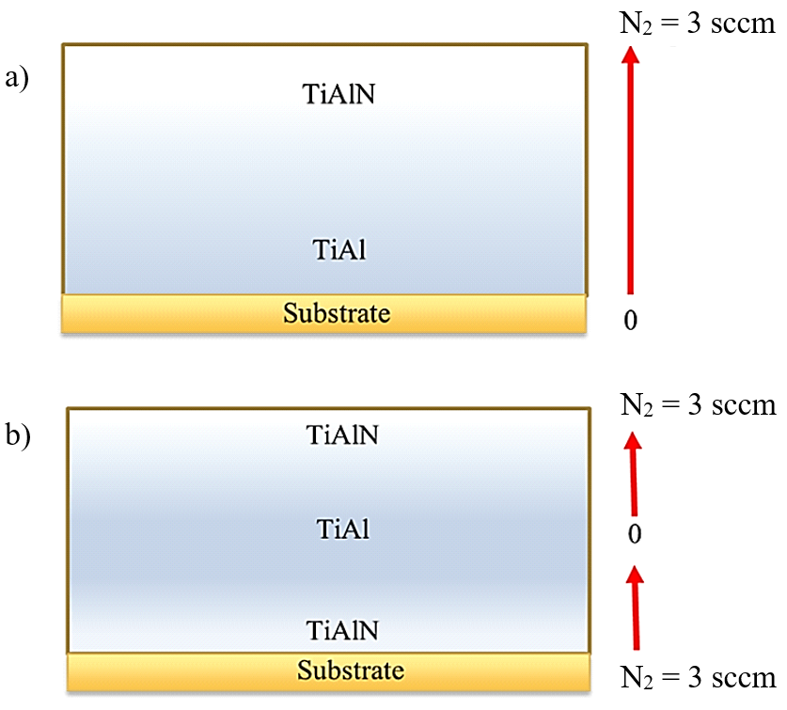

Figure 1. TiAlN gradient films, a) N₂ = 0-3 sccm and b) N₂ = 3-0-3 sccm

Table 1. Deposition conditions

Parameter | Condition
Alloy target Ti/Al (at%)  Substrate  Pressure (mtorr)  Ar flow rate (sccm)  N₂ flow rate (sccm)  Power (W)  Substrate temperature (°C)  Bias (V)  Deposition time (min) | 70/30  Silicon (Si)  3  20  3, 0-3, 3-0-3  150  500  -100  60

Materials and Methods
The TiAlN and TiAlN gradient films investigated in this study were prepared on Si substrate by reactive pulsed DC magnetron sputtering. The alloy target is Ti-Al (70 at% of Ti and 30 at% of Al) with 99.8% purity, a diameter of 50.8 mm, and a thickness of
6 mm. The Si substrates were cleaned with acetone by an ultrasonic cleaner and dried in ambient air. The target-substrate distance was kept at 10 cm.
The vacuum chamber was evacuated to a base pressure of 1×10⁻² mTorr via a coupled turbo-molecular pump and scroll pump. Prior films deposition, pure argon gas (Ar, 99.999% purity) was first introduced to pre-sputter the Ti-Al target for
10 min to remove the oxide on the target surface while the substrate was shielded by the shutter. After pre-sputtering, the reactive gas (N₂, 99.999% purity) was introduced into the chamber to prepare nitride compound films. Both mixing gases were controlled using mass flow controller (MKS Inc., Type 647C). The working pressure was kept at 3 mTorr of all conditions, which was monitored using a vacuum gauge (DCU 400, display control unit with integrated power supply, Pfeiffer Vacuum). During the deposition process, the sputtering power was set at 150 W with a frequency of 50 kHz and a period of 4.0 μs, the substrate temperature was 500°C and the substrate bias was set at -100 V. The N₂ gas flow rate was adjusted according to the gradient distribution, to produce TiAlN and TiAlN gradient films. In order to find the relation between the sputtering condition and the properties of TiAlN films, three deposition parameters were studied: (i) The TiAlN films deposition, the N₂ gas flow rate was fixed at 3 sccm, (ii) The TiAlN gradient deposition, the N₂ gas flow rate with nitrogen gradient distribution increased from 0 sccm to 3 sccm with a rate of 0.2 sccm/4 min (Figure 1(a)). (iii) The TiAlN gradient deposition, the N₂ gas flow rate with nitrogen gradient distribution decreased from 3 sccm to 0 sccm and increased from 0 sccm to 3 sccm with a rate of 0.3 sccm/3 min (Figure 1(b)). For All depositions, the Ar gas flow rate was fixed at 20 sccm. The details of the deposition conditions are listed in Table 1.
The surface morphology and cross-sectional morphology of the TiAlN films were investigated using field emission scanning electron microscope (FE-SEM, Tescan/Mira3, Czech Republic), and
the elemental composition was determined using
an energy-dispersive X-ray spectrometer (EDS). The crystal structure of the TiAlN films was identified by X-ray diffraction (XRD, TTRAX III-RIGAKU) using Cu K_{α} radiation. The films hardness measurement was performed by nanomechanical tester instruments (HYSITRON, SPM Probe Model: ACST Part# ACST-50, USA) and the indentation depth was controlled within 1/10 of the total thickness of films. Finally, the adhesion force of the films was verified by the critical load by the indentation method. The Rockwell spherical diamond indenter with radius of 100 μm was dragged for the track length of 2 mm and sliding speed of 2 mm/min and a loading rate was 9.99 N/min, gradually increasing the load from 0.01 N to 10 N.
Results and Discussion

Crystal Structure
The XRD patterns of the TiAlN and TiAlN gradient films were shown in Figure 2. The dot lines in the figure are the standard XRD patterns of TiAlN (PDF#04-005-5251(RDB)). It can be seen that all the films exhibited diffraction peaks at 37.14°, 43.15°, and 62.66° which are corresponding to the (111), (200), and (220) planes of the TiAlN cubic phase, respectively. However, the intensity of
the diffraction peak of the TiAlN gradient films decreased, which is smaller than that of the TiAlN films. Here, there are two possible reasons that may explain this effect. One is the formation of amorphous phase or nano crystallinity and the other reason is the content of N element in the TiAlN gradient films is lower than in the TiAlN (Barshilia and Rajam, 2004; Das et al., 2016; Lü et al., 2020).
In addition, the diffraction peaks of the TiAlN films are found to shift towards lower angles compared to the standard position, while the TiAlN gradient films showed slight shift. This indicated a larger lattice d-spacing of the TiAlN as compared to TiAlN gradient films. Furthermore, the residual compressive stresses could also contribute to the shifting of the diffraction peaks to the lower angle (Pfeiler et al., 2009). The mean crystallite size (L) of the films was calculated from the full width at half maximum (FWHM) of each peak in XRD patterns using Scherrer equation as shown in Equation (1).
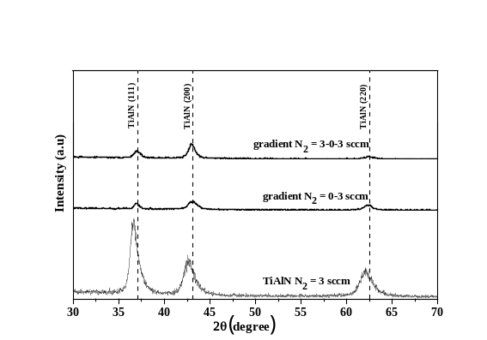

Figure 2. XRD patterns of the TiAlN and the TiAlN gradient films, the dash lines are the standard XRD patterns of TiAlN

$L=\frac{kλ}{β\cos{θ}}$ (1)

where k is a dimensionless shape factor related to crystallite shape with a typical value of about 0.9,
λ is the wavelength of X-ray (nm), β is FWHM in radians, and θ is the Bragg’s angle.
The relation of the d-spacing and lattice parameter (a) of face centered cubic structure and Bragg’s equation are given according to Equations (2) and (3).

$\frac{1}{d^{2}}=\frac{h^{2}+k^{2}+l^{2}}{a^{2}}$ (2)

$2d \sin{θ}=nλ$ (3)

where d indicates the distance between the atomic layers or d-spacing, hkl are the Miller indices, n is an integer. These calculated data of all TiAlN films are shown in Table 2.

Morphology and Elemental Composition
The FE-SEM images of the surface and cross-sectional morphologies of all TiAlN films are shown in Figure 3(a-c). There are no obvious grains are observed on the surface of TiAlN films (Figure 3(a)) with gradient structure, the grains can be seen clearly and spread over surface of the TiAlN gradient films. Additionally, it can be seen from the cross-sectional morphologies that the TiAlN and TiAlN gradient films show different morphology. Moreover, the films thickness is shown in Table 2. The film thickness of the TiAlN gradient films is significantly higher than that of TiAlN films. This is because the TiAlN films are deposited in the compound mode which usually has a low sputtering rate while the TiAlN gradient films are deposited
in the range of metal-transition-compound mode which show higher deposition rate (Berg and Nyberg, 2005).
Table 2. Thickness, crystallite size, d-spacing, lattice parameter, and hardness of the TiAlN and the TiAlN gradient films

Samples | Thickness  (nm) | Crystallite size  (nm) | d-spacing  (Å) |  |  | Lattice parameter  (Å) | Hardness  (GPa)
Samples | Thickness  (nm) | Crystallite size  (nm) | (111) | (200) | (220) | Lattice parameter  (Å) | Hardness  (GPa)
TiAlN films  (N₂ = 3 sccm) | 439 | 8.240 | 2.452 | 2.119 | 1.494 | 4.237 | 32.898
TiAlN gradient films  (N₂ = 0-3 sccm) | 889 | 9.087 | 2.431 | 2.098 | 1.488 | 4.205 | 29.008
TiAlN gradient films  (N₂ = 3-0-3 sccm) | 796 | 9.767 | 2.426 | 2.102 | 1.486 | 4.203 | 22.698

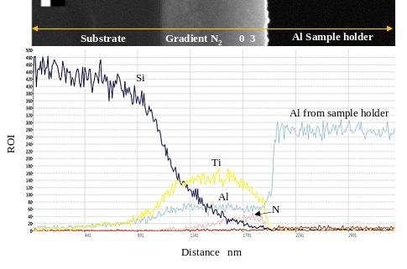

Figure 4. EDS mapping analysis of distribution of the elements in TiAlN gradient films (N₂ = 0-3 sccm)

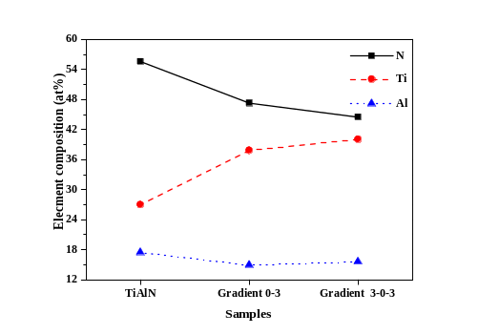

Figure 5. Elemental composition (%) of the TiAlN and the TiAlN gradient films

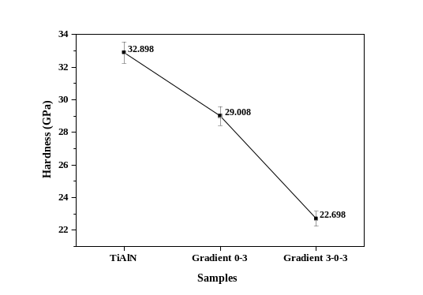

Figure 6. Hardness of the TiAlN and TiAlN gradient films
The distribution of the elements in TiAlN gradient films (N₂ = 0-3 sccm) determined by EDS is shown in Figure 4. It was found that there is
a gradual increase in nitrogen content from the bottom to the top of films, while the content of metal atoms (Ti and Al) is distributed throughout the films. However, the sputtering yield of Ti-Al alloy target reduces with increase of N₂. From EDS mapping, this suggests that the sputtering yield of
Ti decrease when the N₂ gas flow rate increase, while the sputtering yield of Al rather constant. These may be attributed to an effect of nitridation, which introduce the formation of TiN and AlN at the target surface. Ti atoms become hard to sputter out more than Al atoms due to the bond energy of Ti-N is bigger than that of Al-N (Wang et al., 2011). The EDS mapping analysis conditions for N₂ = 3 sccm and N₂ = 3-0-3 sccm (not shown) provided that the transformation analysis results of N₂ were consistent with the experimental conditions. Figure 5 shows the elemental compositions of TiAlN and TiAlN gradient films, which shows the content of N atoms in TiAlN gradient films decreases, while the content of Ti atoms increases but the content of Al atoms slightly decreases as compared to TiAlN films.
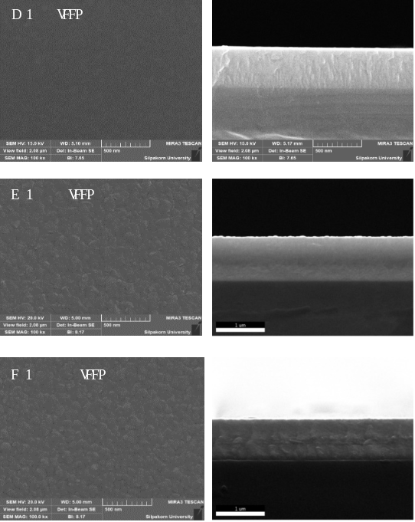

Figure 3. FE-SEM image of surface and cross- sectional morphologies of a) TiAlN films (N₂ = 3 sccm), b) TiAlN gradient films
(N₂ = 0-3 sccm) and c) TiAlN gradient films (N₂= 3-0-3 sccm)

Hardness
Figure 6 shows the hardness of the TiAlN and the TiAlN gradient films. It can be seen that the hardness of the TiAlN gradient films with N₂ varied from 0-3 sccm and 3-0-3 sccm are 29.008 and 22.698 GPa, which is lower by 11.82% and 31.01%, respectively, as compared to the hardness of the TiAlN films. The difference in hardness is in coincidence with the variation of the gradient structure of the films, especially the content of N atoms in the films. The TiAlN gradient films with N₂ vary from 3-0-3 sccm, the hardness is very low. This result indicated that the films do not have enough N element to form the compound TiAlN films. With TiAlN gradient films (N₂ = 0-3 sccm), this gradient structure can increase the N element into the films resulting in increased hardness. Although the films hardness is lower than in the case of TiAlN, the hardness is still quite high.
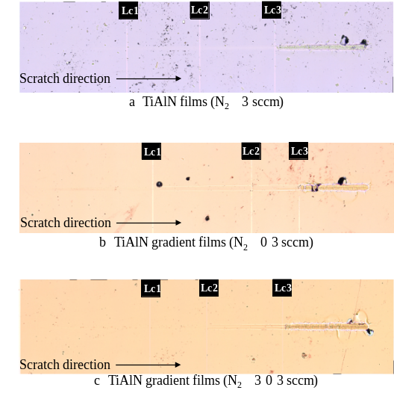

Figure 7. Adhesion force analysis of the TiAlN and TiAlN gradient films from scratch testing

The Scratch Testing
Adhesion force of TiAlN and TiAlN gradient films deposited on Si substrate via reactive pulsed DC magnetron sputtering were carried out by scratch testing. Figure 7 shows the adhesion force analysis of the TiAlN and TiAlN gradient films. In general, Lc1 was defined as the onset of cracking, Lc2 was used as a critical load to define the binding force of the adhesion (Lü et al., 2020), and Lc3 was used as the last load applied to the films without apparent detachment (Gallegos-Cantú et al., 2015). The critical load from the scratch testing of the TiAlN and TiAlN gradient films is listed in Table 3. The critical load values of TiAlN, TiAlN gradient (N₂ = 0-3 sccm) and TiAlN gradient (N₂ = 3-0-3 sccm) were 4.93 N, 4.67 N and 5.12 N, respectively. It can be seen that the adhesion force of the TiAlN films was lower than the TiAlN gradient films due to the TiAlN films showing higher hardness and more residual compressive stresses (Philippon et al., 2011; Cao et al., 2018). Further, TiAlN films occurred in cohesive crack at a lower critical load (Lc1 = 2.70 N) as compared to TiAlN gradient films. This suggests that the gradient structure can significantly enhance the adhesion force of the films.
Conclusions
The TiAlN and the TiAlN gradient films (N₂ = 0-3 sccm and 3-0-3 sccm) were deposited on silicon
by reactive pulsed DC magnetron sputtering. The results revealed that all TiAlN films exhibited
a face-centered cubic structure with orientations in the (111), (200), and (220) crystallographic planes. The results of FE-SEM analysis showed that the film growth had a columnar morphology, especially TiAlN films, while cross-sectional morphology was different. Through the design of the gradient structure, the N element is gradually distributed in the films lead affecting the mechanical properties of films. The deposition of TiAlN gradient films (N₂ = 0-3 sccm) can be enhanced the adhesion force while maintaining the hardness of the films.
Acknowledgments
This study was supported by Thammasat University Research Fund, Contract No. TUFT75/2564. The authors would like to thank the Department of Physics, Faculty of Science, Silpakorn University and the National Metal and Materials Technology Center (MTEC), National Science and Technology Department Agency (NSTDA) for providing the experimental facilities.
References
Barshilia, H.C. and Rajam, K.S. (2004). Raman spectroscopy studies on the thermal stability of TiN, CrN, TiAlN coatings and nanolayered TiN/CrN, TiAlN/CrN multilayer coatings. Journal of Materials Research, 19:3196-3205. https://doi.org/10.1557/JMR.2004.0444.
Berg, S. and Nyberg, T. (2005). Fundamental understanding and modeling of reactive sputtering processes. Thin Solid Films, 476(2):215-230. https://doi.org/10.1016/j.tsf.2004.
10.051.
Bobzin, K., Bagcivan, N., Ewering, M., Brugnara, R.H., and Basturk, S. (2014). Comparison of (Ti, Al) N and (Ti, Al) N/γ-Al2O3 coatings regarding tribological behavior
and machining performance. Surface and Coatings Technology, 257:58-62. https://doi.org/10.1016/j.surfcoat.
2014.08.070.
Cao, H., Qi, F., Ouyang, X. Zhao, N., Zhou, Y., Li, B., Luo, W., Liao, B., and Luo, J. (2018). Effect of Ti Transition Layer Thickness on the Structure, Mechanical and Adhesion Properties of Ti-DLC Coatings on Aluminum Alloys. Materials, 11(9):1742. https://doi.org/10.3390/ma11091742.
Coll, B.F., Sathrum, P., and Fontana, R. (1992). Optimization of arc evaporated (Ti,Al)N film composition for cutting tool applications. Surface and Coatings Technology, 52:57-64. https://doi.org/10.1016/0257-8972(92)90371-G.
Cui, W., Qin, G., Duan, J., and Wang, H. (2017). A graded nano-TiN coating on biomedical Ti alloy: Low friction coefficient, good bonding and biocompatibility. Materials Science and Engineering: C, 71:520-528. https://doi.org/
10.1016/j.msec.2016.10.033.
Das, P., Anwar, S., Bajpai, S., and Anwar, S. (2016). Structural and mechanical evolution of TiAlSiN nanocomposite coating under influence of Si3N4 power. Surface and Coatings Technology, 307:676-682. https://doi.org/
10.1016/j.surfcoat.2016.09.065.
Devia, D.M., Restrepo-Parra, E., Arango, P.J., Tschiptschin, A.P., and Velez, J.M. (2011). TiAlN coatings deposited by triode magnetron sputtering varying the bias voltage. Applied Surface Science, 257(14):6181-6185. https://doi.org/10.1016/j.apsusc.2011.02.027.
Dobrzanski, L.A., Zukowska, L.W., Mikuła, J., Gołombek, K., Pakuła, D. and Pancielejko, M. (2008). Structure and mechanical properties of gradient PVD coatings. Journal of Materials Processing Technology, 201:310-314. https://doi.org/10.1016/j.jmatprotec.2007.11.283.
Gallegos-Cantú, S., Hernandez-Rodriguez, M.A.L., Garcia-Sanchez, E., Juarez-Hernandez, A., Hernandez-Sandoval, J., and Cue-Sampedro, R. (2015). Tribological study of TiN monolayer and TiN/CrN (multilayer and superlattice) on Co-Cr alloy. Wear, 330-331:439-447. https://doi.org/
10.1016/j.wear.2015.02.010.
Håkansson, G., Sundgren J.E., McIntyre, D., Greene, J.E., and Münz, W.D. (1987). Microstructure and physical properties of polycrystalline metastable Ti0.5Al0.5N alloys grown by d.c. magnetron sputter deposition. Thin Solid Films, 153(1-3):55-65. https://doi.org/10.1016/
0040-6090(87)90169-6.
Jiang, S.M., Li, H.Q., Ma, J., Xu, C.Z., Gong, J., and Sun, C. (2010). High temperature corrosion behaviour of a gradient NiCoCrAlYSi coating II: Oxidation and hot corrosion. Corrosion Science, 52(7):2316-2322. https://doi.org/10.1016/j.corsci.2010.03.032.
Jimenez, H., Devia, D.M., Benavides, V., Devia, A., Arango, Y.C., Arango, P.J., and Velez, J.M. (2008). Thermal protection of H13 steel by growth of (TiAl)N films by PAPVD pulsed arc technique. Materials Characterization, 59:1070-1077. https://doi.org/10.1016/j.matchar.2007.08.
024.

Knotek, O., Böhmer, M., and Leyendecker T. (1986). On structure and properties of sputtered Ti and Al based hard compound films. Journal of Vacuum Science and Technology A, 4(6):2695-2700. https://doi.org/10.1116/
1.573708.
Lü, W., Li, G., Zho, Y., Liu, S., Wang, K., and Wang, Q. (2020). Effect of high hardness and adhesion of gradient TiAlSiN coating on cutting performance of titanium alloy. Journal of Alloys and Compounds, 820:153137. https://doi.org/
10.1016/j.jallcom.2019.153137.
Mei, F., Shao, N., Wei, L., and Li, G. (2005). Effect of N₂ partial pressure on the microstructure and mechanical properties of reactively sputtered (Ti, Al) N coatings. Materials Letters. 59(17):2210-2213. https://doi.org/10.1016/
j.matlet.2005.02.068
Musil, J. and Hruby, H. (2000). Superhard nanocomposite Ti1-xAlxN films prepared by magnetron sputtering. Thin Solid Films, 365:104-109. https://doi.org/10.1016/S0040-6090(00)00653-2.
Pfeiler, M., Zechner, J., Penoy, M., Michotte, C., Mitterer, C., and Kathrein, M. (2009). Improved oxidation resistance of TiAlN coatings by doping with Si or B. Surface and Coatings Technology, 203(20-21):3104-3110. https://doi.org/
10.1016/j.surfcoat.2009.03.036.
Philippon, D., Godinho, V., Nagy, P.M., Delplancke-Ogletree, M.P., and Fernandez, A. (2011). Endurance of TiAlSiN coatings: Effect of Si and bias on wear and adhesion. Wear, 270(7-8):541-549. https://doi.org/10.1016/j.wear.
2011.01.009.
Rukkun, J., Aiempanakit, K., Reakaukot, P., Wongpisan, W., Waree, K., and Aiempanakit, M. (2021). Investigation of deposition parameters on the structural properties and hardness of TiAlN films deposited via reactive pulsed DC magnetron sputtering. Journal of Metals, Materials and Minerals, 31(2):118-122. https://doi.org/10.55713/jmmm.
v31i2.1083.
Wang, X., Zhang, K., Yue, G., Peng, D., Qi, Z., and Wang, Z. (2011). Investigation on the Structure and Properties of TiAlN coatings deposited by DC reactive magnetron sputtering. Advanced Materials Research, 154-155:1639-1642. https://doi.org/10.4028/www.scientific.net/AMR.
154-155.1639.

